PHYSICIAN’S STATEMENT
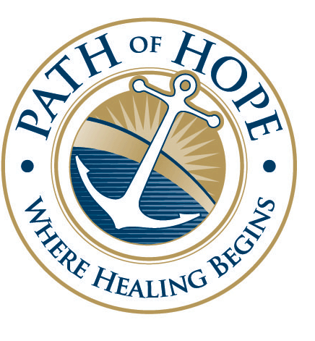
FROM: PHYSICIAN: (print) ______________________________________
Street address: ________________________________________
City, State, Zip Code: ___________________________________
Telephone number: ____________________________________
Fax number: __________________________________________

TO: Path of Hope, Inc.
PO Box 1824
Lexington, NC 27293
Telephone number: (336) 248-8914 Fax number: (336) 248-2138

I HAVE EXAMINED THIS PATIENT:
Name: (print) ________________________________________
Date of Birth: ________________________________________
Social Security Number: ________________________________

And found that he/she is physically fit to participate in the Substance Abuse Treatment Program at Path Of Hope Inc. I have also found that this person is capable of self-administering over the counter medications as directed by product instructions and self-administering the prescribed medications listed below. *Note, client cannot be prescribed or given any opiates or benzodiazepines. Please list all medications given while client was in your facility.
Medications Prescribed | Dosage | Frequency

*Due to N.C. State regulations we are not allowed to let clients at Path Of Hope Inc. take anything that is medicated without a Doctor’s Signed Authorization, this includes both Prescribed and Over the Counter medications. It would be greatly appreciated if this form could be signed in order to allow the above named client to take both the prescribed medications listed above and OTC’s if a need should arise.
Physician Signature Only: ________________________________ Date: __________

